

CLOTHING STORE

Project with structures

Anton Slavov – [asslavov18@codingburgas.bg](mailto:asslavov18@codingburgas.bg)

Radina Velichkova – [RVVelichkova18@codingburgas.bg](mailto:RVVelichkova18@codingburgas.bg)

Volen Mateev – [VPMateev18@codingburgas.bg](mailto:VPMateev18@codingburgas.bg)

Simeon Nikolov – [SRNikolov18@codingburgas.bg](mailto:SRNikolov18@codingburgas.bg)

Mentor: Petar Georgiev

Contents

1.Short description of the project and objectives 1

2. Diagram describing menus 1

3.Description of the functions used 1

Purpose 1

Arguments 1

Returned value 1

# Short description of the project and objectives

The idea of our project is to create a program that would help people in the small and middle business . That's why we wanted to make it easier for the small clothing stores which don’t have their websites and don’t have this type of organization. As we know a lot of small clothing stores in Bulgaria are using reports on paper and don't know how to use the technologies in their business. We think that our project can teach people how to work with different onlineand technology services and how to deal with user interfaces.

# 2. Diagram describing menus

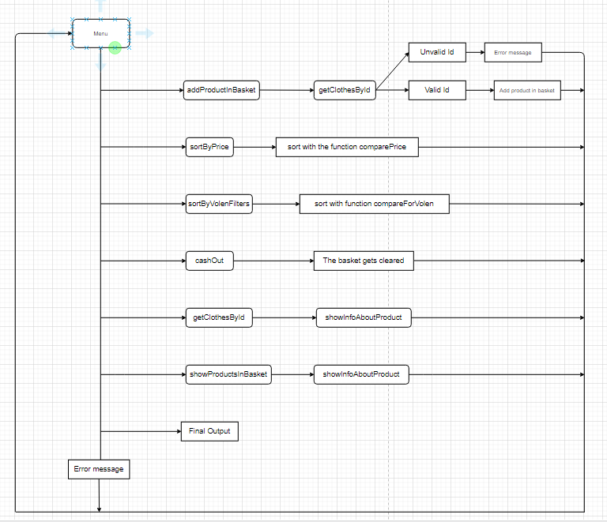

# 3.Description of the functions used

|  |  |
| --- | --- |
| DATA LAYER | PRESENTATION LAYER |
| getClothesById() | **showAllProducts()** |
| addProductInBasket() | **showInfoAboutProduct()** |
| cashOut() | **showProductsInBasket()** |
| comparePrice() | **addNewProductInShop()** |
| compareForVolen() | **Menu()** |
| sortByPrice() | main() |
| sortByVolenFilters() |  |

### Purpose

* getClothesById()-Returns clothes by their id.
* addProductInBasket()- Adds a product in the basket by id.
* cashOut()-Clears the elements in the basket array and couts a message that you have succesfully bought your products.
* comparePrice()-Returns true if the first product has smaller price
* compareForVolen()-Returns true if the first product has to be chosen by Volen's filters
* sortByPrice()- Sorts the clothes by price from lower to higher.
* sortByVolenFilters()- Sorts the clothes by Volen's filters which you can see on line 79 in our code
* showInfoAboutProduct()-Couts info about a CLOTHES variable. The colour is..., the size is..., e.t.c.
* showAllProducts()-Uses the showInfoAboutProduct function for the entire shop[] array.
* showProductsInBasket()- Shows info about all the products in the basket using the showInfoAboutProduct()- function.
* addNewProductInShop()- Adds a products in the shop with

### Arguments

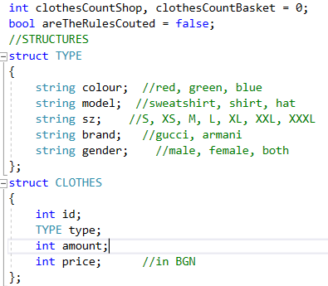

* clothesCountShop(int)-The number of elements in the shop array.
* clothesCountBasket(int)- The number of elements in the basketarray.
* areTheRulesCouted(bool)-True if we have couted the rules of the menu and false if we have not. Helps with the menu function.
* (struct TYPE): colour, model, sz, brand, gender(string)-
* (struct CLOTHES):
  + id(int)-the specific number of the product, can be used in various functions.
  + type(TYPE)-a sctructure about the appearance of a product
  + amount(int)-how many pieces of that clothing we have in the store.
  + price(int)-the amount that you need to pay to buy the product in BGN.
* shop[](CLOTHES)-the data base for our project. All of the data about the clothes in the shop are stored here.
* basket[](ClOTHES)-The basket fiiled with elements from the shop array. It can be cashed out using the cashOut() function.
* product(CLOTHES)-Just a variable that I have declared in a lot of funtions.

### Returned value

The Menu funtion returns true if you want to continue choosing one of the options. However if you want to get out of the the program it returns false and stops the loop in the main function.

.